**Online Quiz and Leader board Platform**

**By: Vishnupriyan P R**

**Roll No:24AM118**

Use Case Diagram :   
  
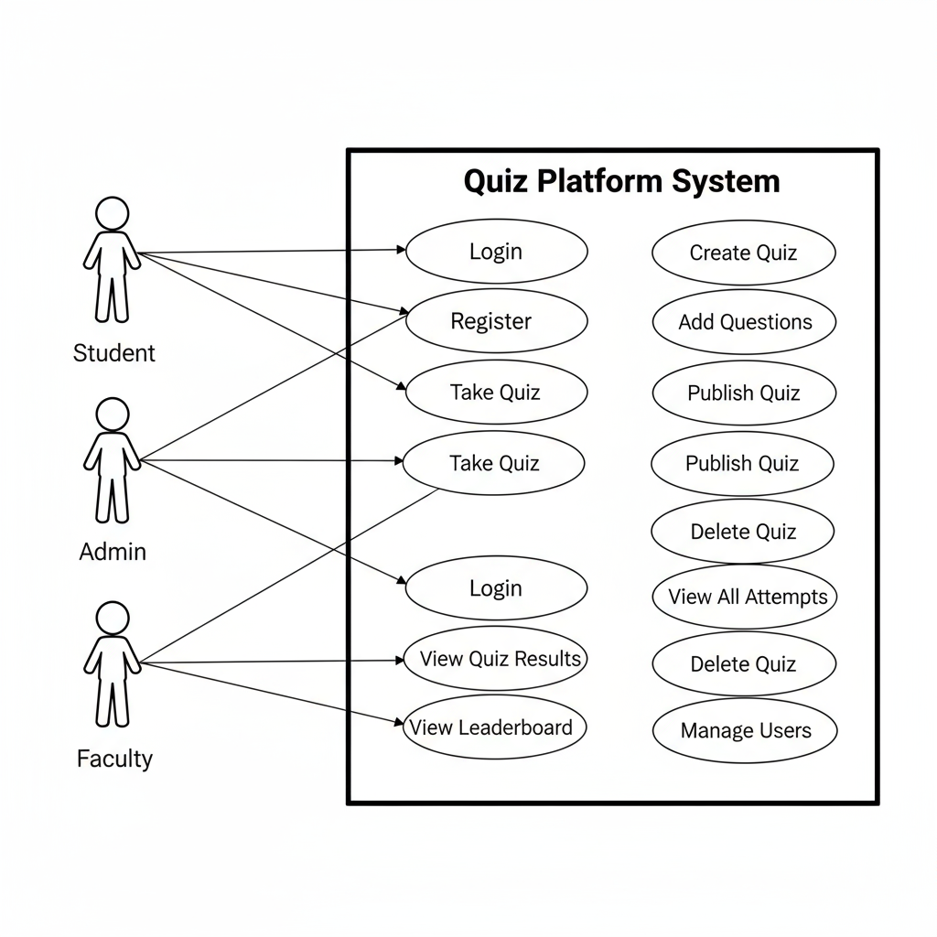

Class Diagram :   
  
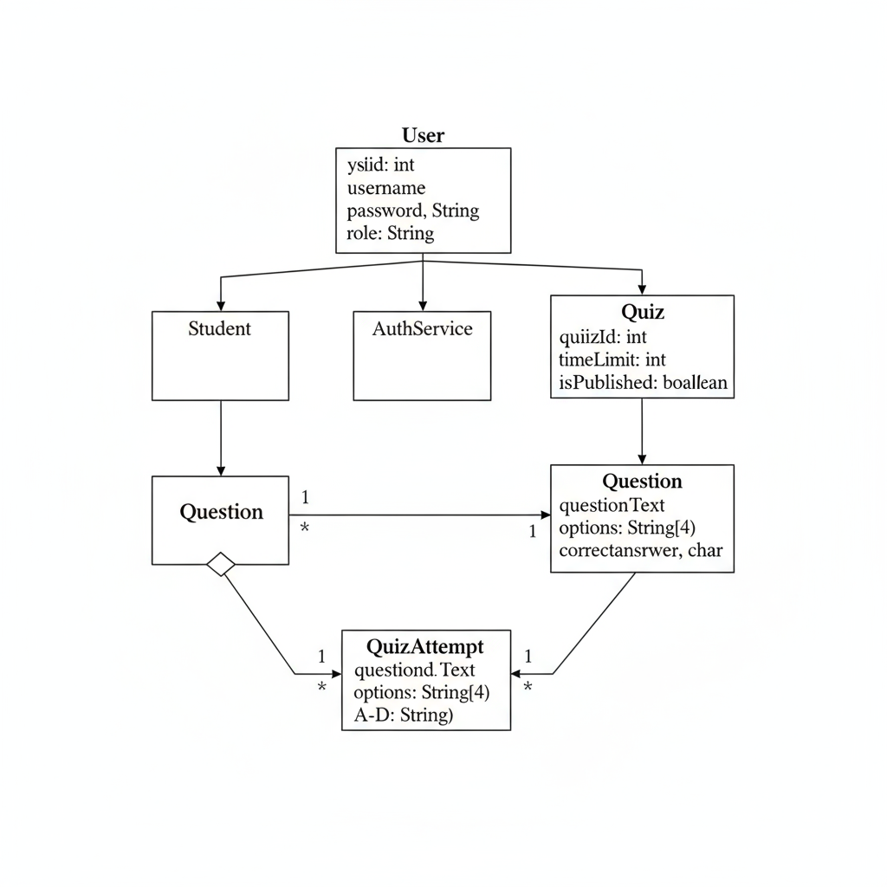

E R Diagram

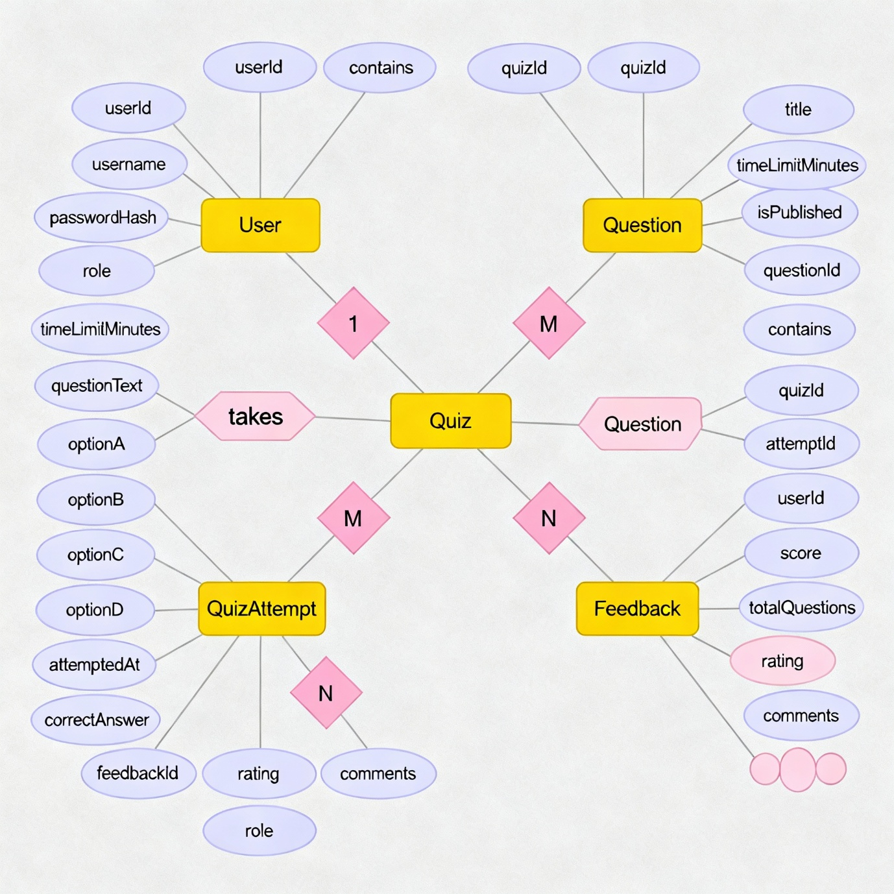

INTERACTION DIAGRAM:

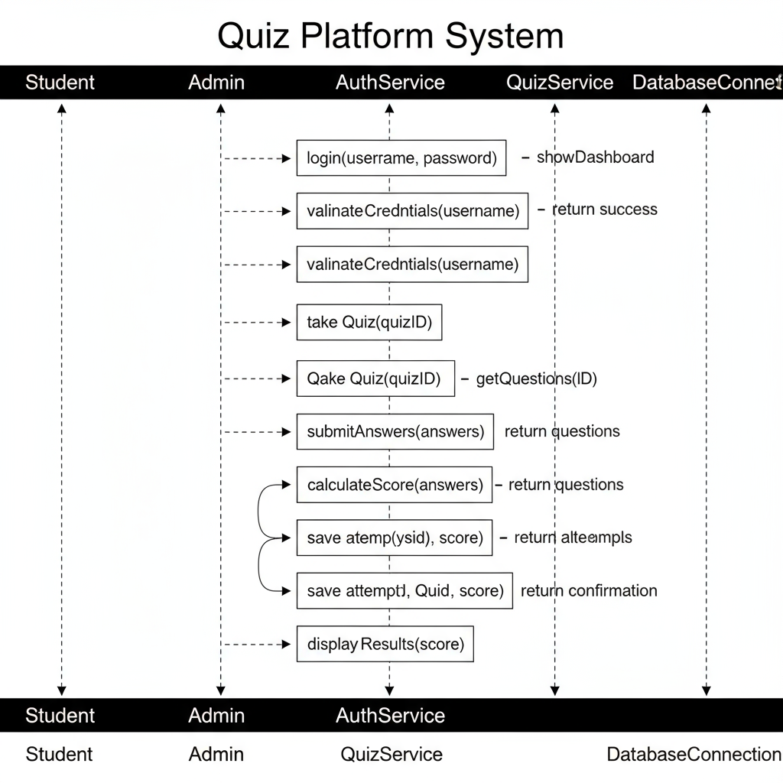

Database Schema :-  
  
